Schedule Appointment

**#1**

*Date Of Appointment : 11/30/2018*

*Preferred Time : Afternoon (12 AM – 4 PM)*

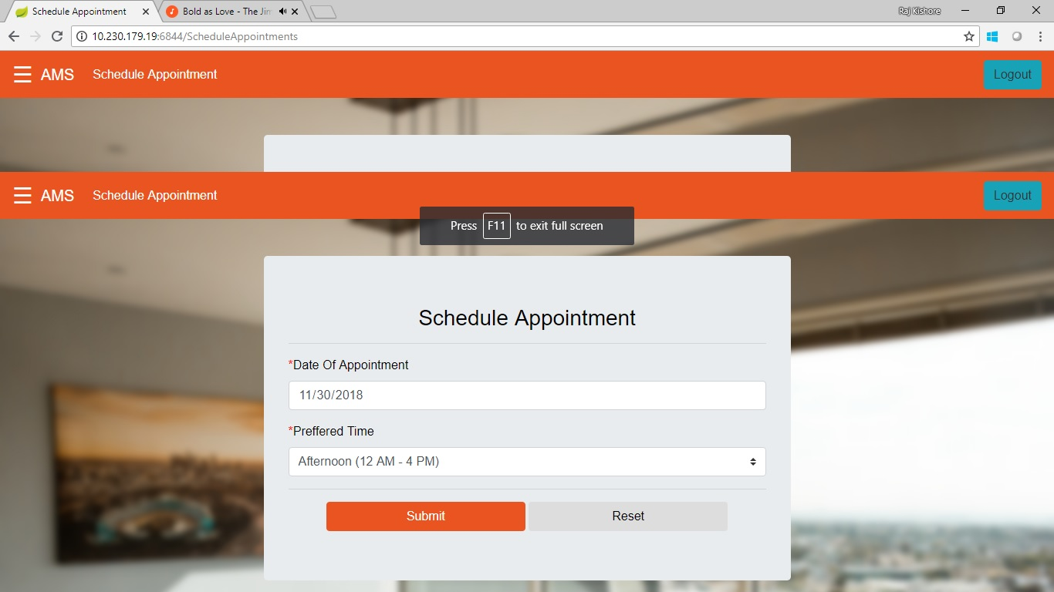

Output:

*Successful*

*Appointment Scheduled On 11-30-2018*

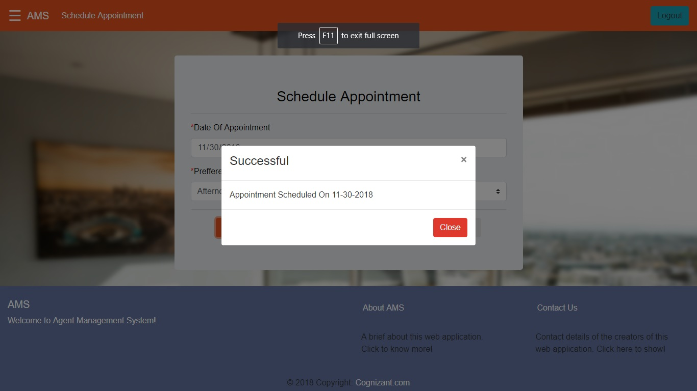

**#2**

*Date Of Appointment : 12/31/2018*

*Preferred Time : Morning (8 AM – 12 PM)*

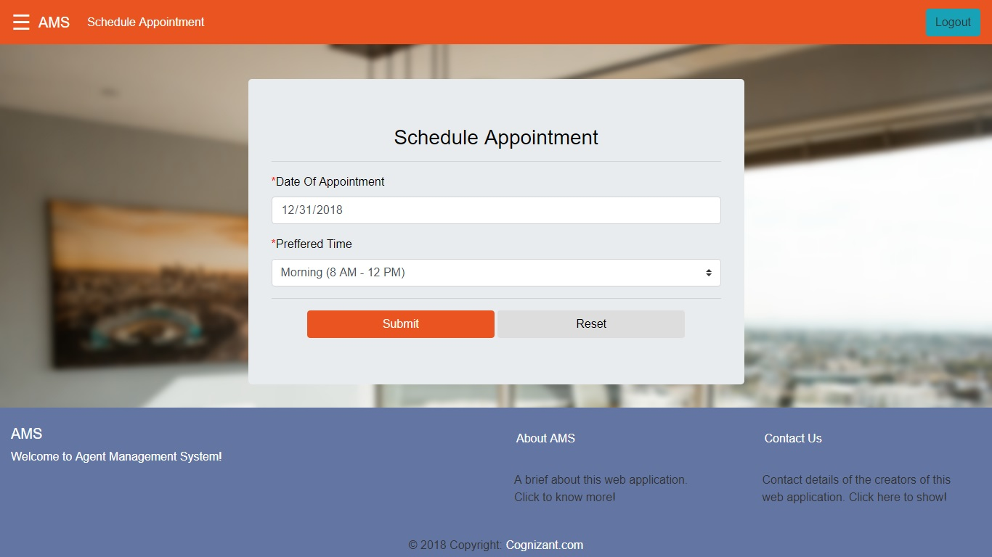

Output:

*Unsuccessful*

*Agents not available for the selected time slot. Please choose another slot or date.*

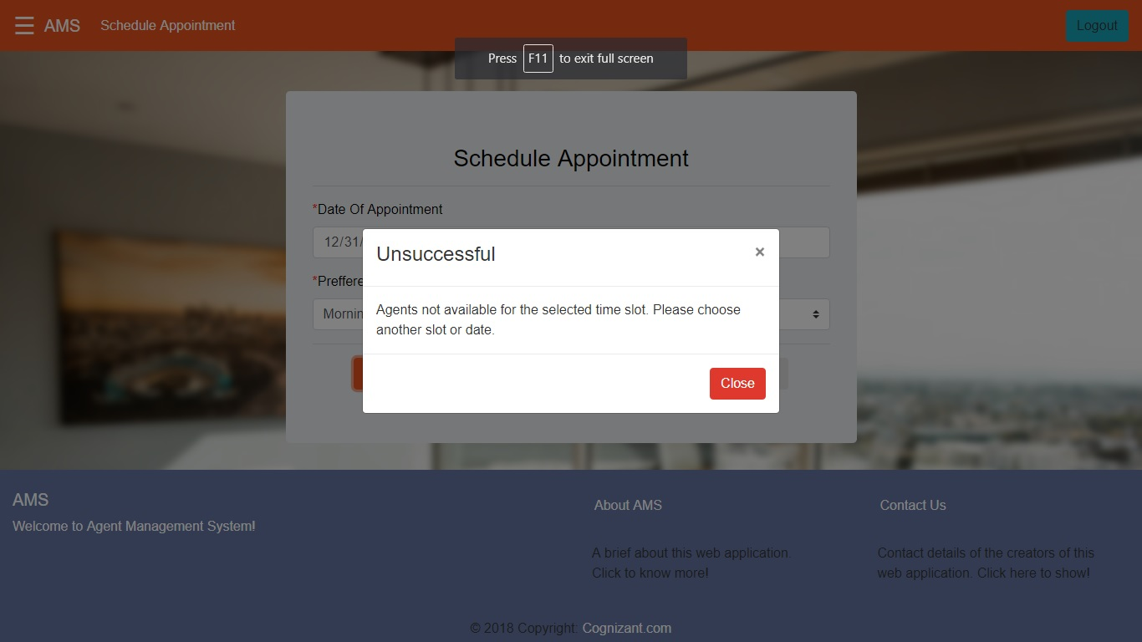

**#3**

Date Of Appointment : 12/31/2018

Preferred Time : Afternoon (12 AM – 4 PM)

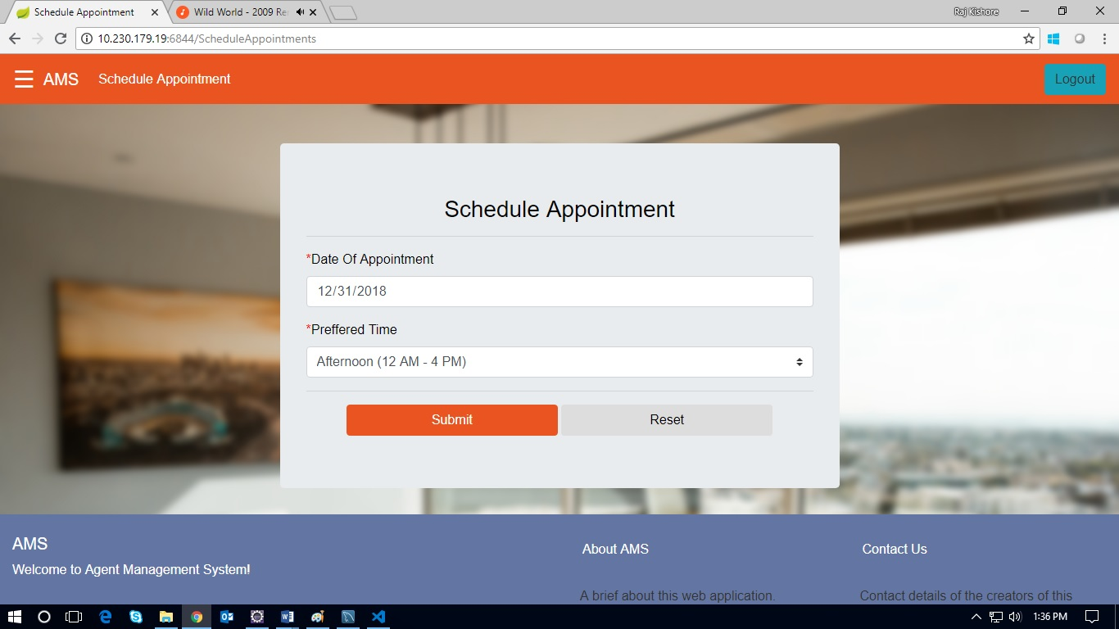

Output:

*Successful*

*Appointment Scheduled On 12-31-2018*

